COACH LINOXYLAKIS NIKOS
K

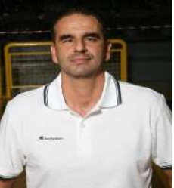
LINOXYLAKIS NIKOS
Coach FIBA License Number:
Position: Head Coach – Assistant Coach
Nationality: Greek
Date of Birth: 06-12-1967
Place of Birth: Greece
LANGUAGES: Greek / English

WORK EXPERIENCE
- 2023 – 2024: Responsible Head Coach for the Quality Development of the Academies of Holargosbc Team and Athletic Director.The Holargos Academy was selected:
• Among the 40 network academies of the Greek Basketball Federation!

• Among the top 50 academies of OPAP after thorough evaluation.

- 2022 – 2023: Responsible Head Coach for the Quality Development of the Academies of Holargosbc Team and Athletic Director. Head Coach of the U16 team of the club.
- The U16 team achieved its entrance to A2’ Division in Athens winning the Championship.
- The U15 Team complete its obligations earned the 5th place in between the 185 teams in this age, in Athens.
- CREATION OF the 4rth group of “CHAMPS”, a team with children belonging to autism, from age 6 to 12, so far.

- 2021 – 2022: Responsible Head Coach for the Quality Development of the Academies of Holargosbc Team and Athletic Director. Head Coach of the Men’s Team, U18 & U21 teams of the club.
- The Men’s team achieved its entrance to A’ Division in Athens winning the Championship.
- The U18 Team complete its obligations earned the 4th place in between the 8 best teams in this age.
- The U14 Team earned the 2nd place in the Junior NBA Championship in Athens.
- Starting point of operation of “CHAMPS”, a team with children belonging to autism. CREATION OF 3 groups from age 6 to 12, so far.

- 2020 – 2021: Responsible Head Coach for the Quality Development of the Academies of Holargosbc. Head Coach of the Men’s Team, Head Coach of U18 Team. The team had no action because of the pandemic. We tried to well -organized everything to be ready for the next year.
- 2019 – 2020: Responsible Head Coach for the Quality Development of the Academies of Holargosbc. Head Coach of U18 & U21 teams of the club.
- The U18 Team achieved its entrance to A’ Division.
- The U21 Team complete its obligations earned the 4th place in between the 8 best teams in this age.
- Starting point of operation of BABY BASKET, 2 groups of children 3 and a half to 5 years old.
- 2017-2019: Assistant Coach in the men’s team of Panionios BC, A1 Division.
LINOXYLAKIS NIKOS
- 2014-2016: Assistant Coach in the men’s team of Panionios BC, A1 Division
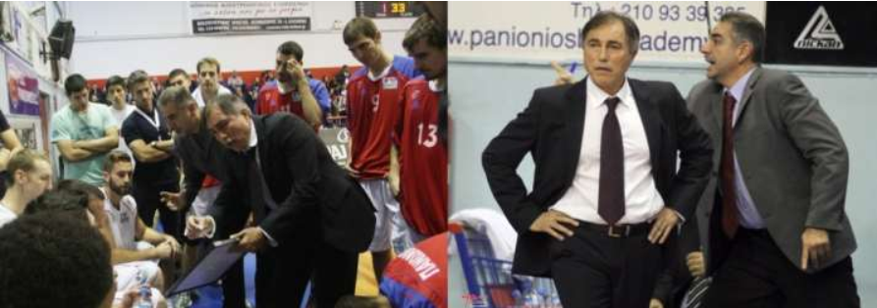
- During the summer of 2013, I’ve been Coordinator of the 1st KIMI BASKETBALL CAMP at Kimi (aged 8 – 17), in association with IMPACT Hellas Company

- .2012-2014: Assistant Coach in the men’s team of Ilissiakos, A1 Division.
1
- 2010-2012: Assistant Coach in the men’s team of Maroussi, A1 Division.
- The team achieved its entrance to the European Cup.
- 2009-2010: Assistant Coach in the men’s team of AEK, A1 Division.
- 2008-2009: Head Coach in the men’s team of Doukas, B National Division.
- 2007-2008: Head Coach in the men’s team of Ikaros, C National Division.
- The team achieved its entrance to B National Division, winning the Championship.
- 2006-2007: Head Coach in the men’s team of Ano Liosia, B National Division.

During Easter of 2006, he attended the Boston Celtics preparation program, against New Jersey Nets and Cleveland Cavaliers, in communication with the Head Coach of Boston Celtics, ‘’Doc’’ Rivers.
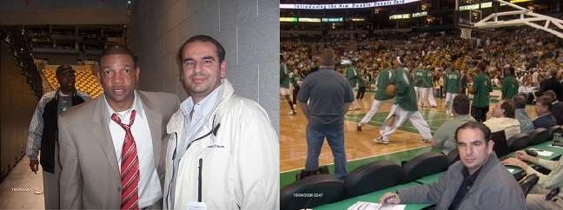

- 2004-2006: Head Coach in the men’s team of Palaio Faliro, A2 National Division.
- 2002-2004: Head Coach in the men’s team of Papagos, A2 National Division.
- 2000-2001: Assistant coach in the men’s team of Papagos, A2 National Division.
- In the summer of 2001, he attended the pre- draft tournament, at Northeastern University in Boston.
- 1998–1999: Head Coach in the men’s team of Papagos in A1 division. The team achieved its entrance in the best 8 Teams in the Koratz European Cup.
- 1998-1999: Head Coach in charge of the Pre-Junior, Junior, Youth and women’s teams and the Preparatory Teams of Papagos.
LINOXYLAKIS NIKOS
- The Junior team of Papagos (aged 15-16) finished 1st in Athens in the championship and won the 2nd place in Greece.
- The Pre-Junior team of Papagos (aged 13-14), won the 1st place in the international tournament, held in Belgium.
- Head Coach of the All-Around Athens team 17-18 years old, competing in Lamia, for the Panhellenic tournament.
- 1999 – now: Teacher in Public Primary Schools, having two specialties, as a teacher of General Education and teacher of Physical Education (Π 70 – Π 11).
- 1997-1998: Responsible Coach for 43 Teams of the Northern Suburbs of Athens with the responsibility of scouting for the best players in the age groups of 15-16 years old, in order to participate in the All-Around Tournament in Athens.
2
- 1997-1998: Assistant Coach in the men’s team of Papagos in A1 division.
- The team achieved its entrance to the European Cup
- 1994-1996: Assistant Coach in the men’s team of Papagos A2 Division which advanced from A2 to A1 Division.
- 1990-1991: Head Coach and Responsible for the selection of the best ranking players in Athens (AGED 13-14 years).
- This team won the 2nd place in Athens.
- 1984-2000: Head Coach in the Papagos junior team (under 17-18 years old) and General Responsible Technical Advisor of the Academies.

EDUCATIONAL STATUS
- Graduated from Papagos High School with point grade average 18.6.(EXC). Graduated from the University of Athens – Faculty of Primary Education.
- Graduated from the University of Athens - Faculty of Physical Education and Sport Science in Athens.
- Specialization in Basketball Coaching.
- 1 year of postgraduate studies on the History and Philosophy of Applied Mathematics.
.SPORTS CAREER
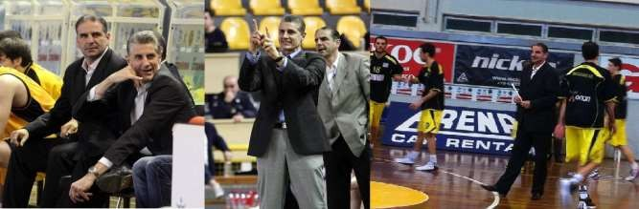
- 1977-1998: Pro-player in Division A2 - A1 for Papagos Basketball team.

LINOXYLAKIS NIKOS

3

